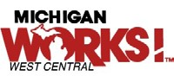

Workforce Innovation and Opportunity Act

Region 4 Plan

PI 16-02c1

Section 106(c)(1) of the WIOA requires local boards and chief elected officials in each planning region to engage in a regional planning process that results in the preparation and submission of a single regional plan. Michigan Works! West Central’s (Region 4a), local plan can be found [at www.michworkswc.org a](http://www.michworkswc.org/)nd West Michigan Works! (Region 4b) local plan can be found at [www.westmiworks.org.](http://www.westmiworks.org/)  Both Michigan Works! West Central and West Michigan Works! have collaborated and are committed to the development and growth of the following elements:

1. **A description of the planning process undertaken to produce the regional plan:**

Region 4 has two MWAs: Michigan Works! West Central (MWWC) and West Michigan Works! (WMW). Planning for the region occurs in many different facets however the primary connector is the committed participation both agencies have with Talent 2025. Talent 2025 works with stake holders in business and education to ensure and ongoing supply of world-class talent for West Michigan. Collectively they are composed of over 100 CEO’s from the 13 county region with a mission to embrace the industry sectors and facilitate and efficient collaboration that integrates resources, streamlines processes, and leverages energies to address talent demand needs. Michigan Works! West Central and West Michigan Works! also, collaborate on National Emergency Grants (NEG) applications and promote Skilled Trades Training Funds (STTF) throughout the region. These types of partnerships provide consistency throughout the region while recognizing the unique needs of our communities and employers.

Representatives have attended joint training sessions in relation to regional planning and talked about joint data and approaches, as well as the continued importance of “Regional Thinking.” Each partner agency has shared draft planning information and meets as needed to exchange ideas and discuss proposed goals, priorities, and Industry Clusters. The economy of Region 4 is largely self-contained, so the focus of training will recognize employment and Industry Clusters showing demand on a regional basis.

1. **An analysis of regional labor market data and economic conditions:**

Knowledge and Skills Necessary to Meet Employer Needs

Current Labor Market information (LMI) for West Michigan, provided by the DTMB, Bureau of

Labor Market Information and Strategic Initiatives, and Quarterly Census of Employment and Wages (QCEW), shows that Construction and Manufacturing, along with Professional and Business Services are leading all industries in talent needs. Education and Health Services, Transportation and Utilities, along with Leisure and Hospitality are following slightly behind. Private sector jobs continue to grow overall with the greatest change from 2011 to 2017. West Michigan outperformed the state in private sector job growth in every industry except for Professional and Business Services.

**Table 8 - Private Industry Employment Trends - 2011 - 2017**

|  |  |  |  |  |  |  |
| --- | --- | --- | --- | --- | --- | --- |
| **Industry** | **Second**  **Quarter 2011** | **Second**  **Quarter 2013** | **Second**  **Quarter 2015** | **Second**  **Quarter 2017** | **2011 -**  **2017**  **Numeric**  **Change** | **2011 - 2017 Percent**  **Change** |
| Total Employment | 537,418 | 577,556 | 618,142 | 656,486 | 119,068 | 22.2% |
| Natural Resources and Mining | 10,817 | 11,183 | 12,606 | 12,528 | 1,711 | 15.8% |
| Construction | 22,087 | 23,789 | 27,172 | 30,639 | 8,552 | 38.7% |
| Manufacturing | 122,871 | 134,980 | 145,967 | 155,036 | 32,165 | 26.2% |
| Trade, Transportation, and Utilities | 108,346 | 113,236 | 122,701 | 125,778 | 17,432 | 16.1% |
| Information | 6,163 | 6,282 | 6,091 | 6,346 | 183 | 3.0% |
| Financial Activities | 24,153 | 26,607 | 26,296 | 27,984 | 3,831 | 15.9% |
| Professional and Business Services | 79,038 | 86,228 | 93,239 | 104,702 | 25,664 | 32.5% |
| Education and Health Services | 89,877 | 95,107 | 100,584 | 105,861 | 15,984 | 17.8% |
| Leisure and Hospitality | 55,283 | 59,611 | 62,547 | 65,661 | 10,378 | 18.8% |
| Other Services | 18,783 | 20,533 | 20,939 | 21,951 | 3,168 | 16.9% |

**Source: DTMB, Bureau of Labor Market Information and Strategic Initiatives, Quarterly Census of Employment and Wages (QCEW)**

High demand occupations within West Michigan’s *Construction* Industry include job titles such as carpentry, civil engineers, cost estimators, plumbers, heating and air mechanics and installers, and first line managers and laborers. The Construction Workforce Development Alliance of West Michigan (CWDA) was created by the [Associated Builders and Contractors Western Michigan](http://www.abcwmc.org/)

[Chapter (](http://www.abcwmc.org/)ABCWM), [American Subcontractors Association of Michigan](https://asamichigan.net/) (ASAM), and [Home Builders Association of Greater Grand Rapids](http://mygrhome.com/) (HBAGGR) and includes a collaborative of partners including workforce development, educators and construction employers. Although this council is primarily serving Region 4b, there is room for expansion based on employer need.

High demand occupations within West Michigan’s *Manufacturing* Industry include automotive, aerospace, pharmaceuticals, food production, machinery manufacturing, plastics product manufacturing, and machine shops. Region 4b is a key stakeholder in facilitating and maintaining the Discover Manufacturing council that includes employers, community partners, and training providers who all share the mission of expanding talent throughout West Michigan.

Recent projects of this council include Manufacturing Week, MiCareerQuest, promotion of Going Pro Apprenticeship Readiness Pilot Program, Adopt a School Program, Talent Pipeline Management (TPM) Employer Collaborative, M-CAM Mobile Manufacturing Lab, a partnership with Talent 2025 to conduct demand forecasting and better connect educational curriculum to employer needs, and the development of an updated Discover Manufacturing website (www.discover-manufacturing.com) that allows students, parents, educators, and employers to stay connected and engaged in manufacturing.

Within the *Healthcare* industry the job titles include: physicians, surgeons, dentists, technicians, RN, LPN, physicians assistants, home Health aides and medical assistants. These occupations continue to show regional growth and Michigan Works! West Central and West Michigan Works! are collectively focused on growing the talent pipeline in this area.

The *Professional* occupation includes higher skilled and educated positions such as mathematical analysis, architecture, and art and designer.

West Michigan is also focused on the Transportation and Utilities industry and is addressing the employer needs by participating in state lead conversations that include employers, training providers, and workforce development staff regarding innovative ways to recruit, train, and retain qualified candidates. Both Michigan Works! West Central and West Michigan Works! offers training scholarships and career services for individuals under the Workforce Innovation and Opportunity Act (WIOA) who are interested in pursuing this career choice to include those who are considered hard to serve and re-entering citizens.

These occupations include employment opportunities for high school completers through those holding graduate or professional degrees. This trend aligns well with the goals of WIOA and will allow career pathway development and apprenticeship opportunities for those individuals who are accessing the workforce system.

Private sector jobs continue to grow overall with the greatest change from 2011 to 2017. West Michigan outperformed the state in private sector job growth in every industry except for Professional and Business Services.

As of the second quarter of 2017, approximately 19,600 jobs were advertised online in West Michigan, according to the Conference Boards’ Help Wanted Online Database. This is a decline of 4,300 ads since the 1st quarter 2016. The top job advertisements were for Registered Nurses with Heavy and Tractor-Trailer Truck Drivers and First Line Supervisors of Retail Sales Workers close behind.

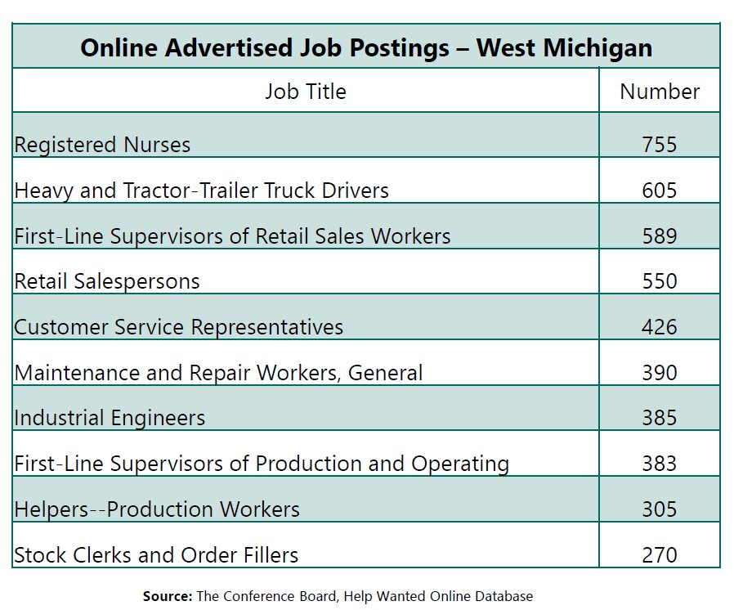

The analysis on the projected occupational growth rates is suggesting that 44 percent of West Michigan jobs will still only need a high school diploma or less with short term or on-the-jobtraining. 34 percent of the jobs will require an Associate’s Degree, post-secondary training, some college with no degree, or a high school diploma or less accompanied with an extensive apprenticeship or on-the-job-training experience. Approximately 22 percent of the jobs will require a Bachelor’s Degree or higher. These projections mirror with the projections for the State of Michigan overall, however the growth rate in West Michigan will supersede the state average before arriving at these outcomes.

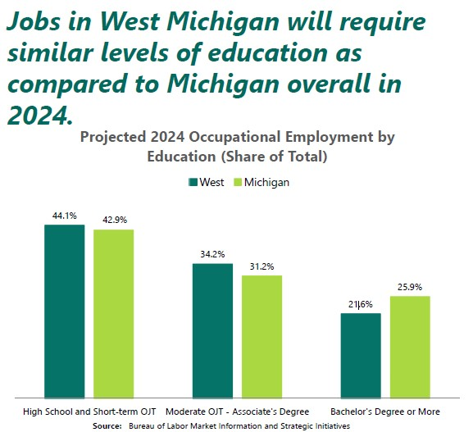

When comparing high-demand, high-wage jobs with educational requirements, *Registered Nurses* are expected to have the most annual openings according to the Bureau of Labor Market Information and Strategic Initiatives. *Physical Therapists* are showing the greatest growth percent with a fairly high median hourly wage. *General and Operational Mangers* are showing the highest wages but the least amount of growth. This completed research confirms that pay level is directly correlated with the level of formal education and/or the length of the job training or apprenticeship.

Analysis of Current Workforce

An Analysis completed by the State of Michigan’s Department of Technology, Management and Budget Bureau of Labor Market Information and Strategic Initiatives provides the population estimate for West Michigan Prosperity Region 4 was at 1,596,000 people in 2017 (US Census Bureau). This is a 4.5 percent increase over 2011-2017, while the statewide population showed an increase of only 0.9 percent. The data shows that much of the increase was in Kent County, totaling more than 40,000 new residents. While West Michigan as a region was growing during this time (2011-2017) Mecosta, Newaygo, Osceola, Oceana Counties slightly lost population.

**Table 1 - Population Trends - 2011 – 2017**

|  |  |  |  |  |  |  |
| --- | --- | --- | --- | --- | --- | --- |
| **Area** | **2011** | **2013** | **2015** | **2017** | **2011 -**  **2017**  **Numeric**  **Change** | **2011 -**  **2017**  **Percent**  **Change** |
| West Michigan  Prosperity Alliance | 1,523,804 | 1,547,930 | 1,570,291 | 1,595,965 | 72,161 | 4.5% |
| Allegan | 111,137 | 111,946 | 114,085 | 116,447 | 5,310 | 4.6% |
| Barry | 58,911 | 59,076 | 59,389 | 60,586 | 1,675 | 2.8% |
| Ionia | 63,853 | 63,982 | 64,051 | 64,291 | 438 | 0.7% |
| Kent | 608,174 | 623,457 | 636,508 | 648,594 | 40,420 | 6.2% |
| Lake | 11,454 | 11,390 | 11,693 | 12,013 | 559 | 4.7% |
| Mason | 28,633 | 28,647 | 28,721 | 29,073 | 440 | 1.5% |
| Mecosta | 43,424 | 43,205 | 42,987 | 43,391 | -33 | -0.1% |
| Montcalm | 63,245 | 62,765 | 62,728 | 63,550 | 305 | 0.5% |
| Muskegon | 169,975 | 172,196 | 172,373 | 173,693 | 3,718 | 2.1% |
| Newaygo | 48,310 | 47,844 | 47,863 | 48,242 | -68 | -0.1% |
| Oceana | 26,450 | 26,264 | 26,287 | 26,442 | -8 | 0.0% |
| Osceola | 23,468 | 23,310 | 23,167 | 23,260 | -208 | -0.9% |
| Ottawa | 266,770 | 273,848 | 280,439 | 286,383 | 19,613 | 6.8% |
| **Michigan** | 9,876,199 | 9,899,219 | 9,918,170 | 9,962,311 | 86,112 | 0.9% |
| **United States** | 311,644,280 | 316,234,505 | 321,039,839 | 325,719,178 | 14,074,898 | 4.5% |

**Source: U.S. Bureau of the Census, Annual Population Estimates**

Further research conducted by this same source demonstrates the current workforce trends within Region 4. The data below will provide an accurate analysis of the labor force by demographics and education attainment levels.

On par with the increase in population, the labor force has also increased for a total workforce population of 824,432. With this increase, the area still maintained unemployment trends that followed both the state of Michigan trends and the United States trends of steady decrease since 2011. From 2011 to 2017, West Michigan went from a 9.1 percent unemployment rate to a 4.0 percent unemployment rate landing 0.6 percent below the Michigan average and 0.4 percent below the United States average.

Looking at jobless rates by demographics, West Michigan experiences rates below the State average in every category except the Native American populations. Males age 16 and over show a slightly higher unemployment rate than females age 16 and over; however, this rate is still below the state average in both categories. West Michigan’s highest jobless rates are found within the sub category of males age 16-19 showing almost 23 percent, female age 16-19 showing 19 percent and Black/African American showing just over 16 percent.

When looking at the data provided by the U.S. Bureau of the Census, 2012-2016 American Community Survey Five-Year Estimates, the number of older workers staying in the labor market longer in West Michigan is slightly less than the State average. During 2012-2016, this group has had a 39 percent workforce participation rate (employed or seeking work) which is an increase of 2 percent. Overall, the total population and labor force rates remain slightly higher than the State average.

Poverty rates for West Michigan are just slightly below the state average with an estimated 17 percent of residents living below the poverty line. When broken down by demographics, West Michigan is fairly close to the State averages in all categories with the biggest exception being Hispanics which is showing a poverty rate of 15 percent higher. The data also shows a larger percentage difference in West Michigan between White, 12 percent falling below the poverty line, and Black/African American, 33 percent falling below the poverty line.

According to the Michigan Department of Health and Humans Services (MDHHS), there are approximately 46,610 welfare registrants in West Michigan. Both Female and Male registrants were fairly close with females making up almost 56 percent in Michigan, compared to the males making up 44 percent.

Based off of the U.S. Bureau of the Census, 2012-2016 American Community Survey Five-Year Estimates, West Michigan has a lower jobless rate compared to the state for white, Black/African American, and Asian Individuals. However, African Americans have the highest jobless rate in the region among racial groups, at 16 percent over the 2012-2016 period.

According to the Michigan Department of Health and Human Services, roughly 46,900 assistance program registrants resided in West Michigan as of June 2017. This number is down by 18,500 individuals since December 2014. Over 60 percent of the assistance program registrants were white while only 18 percent were Black or African American. This data suggests that the Black or African American population is accessing welfare reform services at a much lower level.

Individuals with a reported disability account for 199,000 of West Michigan’s population. The demographic characteristics are similar to the State average with the biggest variance being between the white (86 percent) and Black / African American (8 percent) populations. The percentage of male and female individuals with disabilities in West Michigan is on par with the State average in both categories with the male to female share in the region being 49 percent to 51 percent.

Educational attainment is based on the number of residents 25 and older. In Michigan, that number includes 1,021,053 residents. Overall, the attainment rate for West Michigan is consistent with the overall state average; however, individuals holding Bachelors’ Degrees out performs the State average by 3 percent. The chart below demonstrates the educational attainment levels through 2024 for West Michigan in comparison to the State of Michigan.

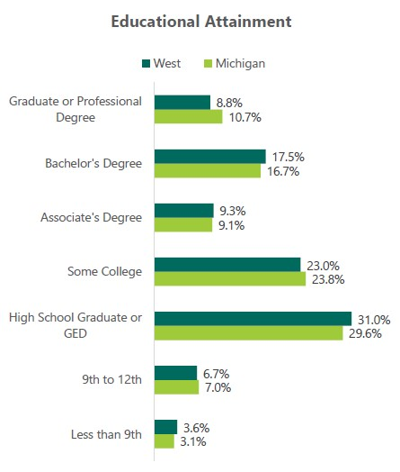

Analysis of Workforce Development Activities

Although West Michigan has experienced population increases, a steady decrease in unemployment rates, and slightly better than state averages in most of the workforce trends, it remains a region in need of intentional workforce development. This includes seeking ways to provide access to those not currently utilizing the welfare reform or other workforce systems, provide one stop barrier removal services in coordination with existing and newly sought out community partners, better prepare individuals to attend various training opportunities, and finding ways to increase the labor force by re-engaging people with disabilities who are otherwise capable of working. Michigan Works! West Central and West Michigan Works! are relentlessly pursuing innovative and relevant solutions to these challenges through unique partnerships and resources to meet individual and employer needs.

Using sector strategies, the Region 4 Michigan Works! agencies continue to convene and connect to create a network of partners to meet the demands of the region’s current employers as well as the emerging industry needs in order to achieve a skilled workforce.

As previously mentioned, Industry Councils are being established within the region to help identify employer needs from the industry-wide perspective. These councils allow for the identification of best practices and shared strategies as well as increased articulation of what areas employers may need workforce development assistance.

Key roles of each of the industry sector councils include:

* Information conduit; sharing trends and best practices affecting talent.
* Talent Initiatives; leading, supporting and promoting talent initiatives throughout West Michigan.
* Training Needs; sharing current training needs with educational partners to develop curriculum, create career pathways and nurture a supply chain of talent.
* Networking; promoting networking among employers, educators, workforce development and economic development professionals for the purpose of developing a skilled workforce.

Educating youth and enhanced outreach activities allows for a better understanding of what the regional economy looks like and what career opportunities are in existence post high school or following postsecondary education. Building the talent pipeline will increase the skilled talent pool and retain young people in our area. MiCareerQuest (http://www.micareerquest.org), a region wide career exploration event for youth, Jobs for Michigan Graduates (JMG) and the Summer Youth Work Experience Program are all examples of current workforce development activities targeted at increasing the local labor force and addressing the education and skill gaps in our region.

West Michigan is also focused on identifying and advocating to provide more meaningful and efficient services to individuals with disabilities. These initiatives include addressing the infrastructure improvements needed to lessen the barriers brought by housing, transportation, and internet access as well as increasing the training and employment opportunities that are available to this population. Michigan Rehabilitation Services (MRS) is a core partner and a representative is co-located inside of many of the service centers. In addition, West Michigan has established relationships with Michigan Bureau for Blind Services, Disabilities Advocates, and Disability Connections. These agencies are sharing resources and are at the table investigating ways to share common intakes, assessments, and making direct connects to opportunities.

In rural areas or where public transportation is unavailable, support services, such as gas cards or auto repairs, may be provided to assist individuals with getting to and from workforce development activities including education and employment. Though the causes of transportation barriers are different, these barriers exist in both urban and rural areas of the region.

Adult Education and Literacy programs are made available through established and emerging partnerships with local providers. Some of the West Michigan Region 4 Service Centers provide instruction and testing onsite or through direct services. In areas that have expanded resources, community conversations and informational tours are taking place to increase awareness of workforce development services. In some communities, Michigan Works! staff conduct workshops and initiate career coaching as part of the educational curriculum.

Short term Occupational Skills Training and Higher Education opportunities are also available throughout the region and are funded with local WIOA Adult, Dislocated Worker and Youth allocations for those who qualify. Region 4 works closely with training providers to ensure that the supported programs lead to an industry recognized credential and that the credential falls in line with employer demand. Recent initiatives have also shown that training providers including community colleges are responsive to the development and delivery of a curriculum that directly addresses the skill gaps.

The geographic factors of Region 4 presents many challenges to both the rural communities and employers. Although some training opportunities are offered online, many are only available in the urban areas making transportation a barrier that often discourages individuals from pursuing Occupational Skill Training or Higher Education. Commuting patterns suggest that many people living in the rural areas are working in urban locations however there is still a large gap presented for both employers and residents when they are not able to obtain the skills needed to live and work in the same community. Efforts to better assess training needs and accessibility of training programs are being made in collaboration with the West Michigan Industry Councils, Higher Education providers, Vocational Training partners, Michigan Rehabilitation Services (MRS), Adult Education providers, Veterans Services, and other community partners.

Work-based training is available and is a viable option that allows individuals to learn the skills that employers need without attending an occupational skills based or higher education training. Depending on the desired skill, the training type and the length of the training, this may assist residents with employment opportunities that will require an education attainment of high school diploma through Associates Degree (approximately 80 percent of projected jobs). Workbased training can be funded with local WIOA Adult and Dislocated Worker allocations and for those who qualify, this is a very desirable option.

Work-based training opportunities include:

* *On-The-Job-Training*– intended to provide a participant with the knowledge and skills necessary for the full performance of the job. OJT is a critical tool that can help job seekers enter into successful employment. The term ‘‘on-the-job training’’ means training by an employer that is provided to a paid participant while engaged in productive work in a job that:

* + Provides knowledge or skills essential to the full and adequate performance of the job;
  + Provides reimbursement to the employer of up to 75 percent of the wage rate of the participant for the extraordinary costs of providing the training and additional supervision related to the training; and
  + Is limited in duration as appropriate to the occupation for which the participant is being trained, taking into account the content of the training, the prior work experience of the participant, and the service strategy of the participant, as appropriate.

* *Pre-Apprenticeship Training*– designed to provide work experiences that can help participants obtain the skills needed to be placed into a registered apprenticeship.

* *Registered Apprenticeships*– designed to combine paid learning on-the-job and related technical and theoretical instruction in a skilled occupation. This training is an important component of the education and training services that the workforce system can provide to its participants, and should be used as a strategy to train and employ job seekers. Registered Apprenticeships offer job seekers immediate employment opportunities that usually pay higher wages and offer continued career growth.

* *Customized Training* –aimed at meeting the special requirements of an employer with a commitment to employ after successful completion of the training.

* *Incumbent Worker Training* – designed to assist employers with training current workers in specific circumstances to meet the needs of employers and increase the skill level of workers.

* *Transitional Jobs*– designed to work with employers to assist individuals with barriers to employment who are chronically unemployed or have an inconsistent work history. The goal is to establish a work history, demonstrate work success, and develop skills for the individual that will lead to employment. Employers assisting in this realm have no obligation to hire the individual after the training is completed.

1. **A description of regional service strategies that have been or will be established as a result of coordinated regional analysis and delivery of services:**

**Regional service strategies that are being established in coordination with region 4a and 4b include a strong focus on building the talent pipeline through education and training, apprenticeships, strengthening our partnerships with adult education, and intentional inclusion efforts.**

**With the recent addition of the Apprenticeship Success Coordinators, the Business Services Teams have been working together across the region to engage with employers in order to increase their awareness of USDOL Registered Apprenticeships opportunities. This ongoing campaign includes region wide *Apprenticeship in a Day* workshops designed for both employers and educators.**

**The Going Pro Talent fund has also utilized regional strategies, especially for those employers who are interested in participating and frequently share the labor shed with the bordering counties.**

**Both Michigan Works! West Central and West Michigan Works! Actively participate and attend monthly meetings with the Adult Learning Partners of West Michigan (ALPWM), a region wide collaborative group that includes adult education providers from all thirteen counties. Not only does Pat Walstra, Region 4 Adult Education Consultant, serve as a regional connect for ALPWM, she is also a member of the Region 4 Career Education Advisory Council (CEAC). The mission of this group is to provide coordinated education and job skills training programs which lead to job attainment, post-secondary education and productive members of our community.**

**Tangible examples of this coordination include *Linked Muskegon* and *Career Connect*, two programs offered in partnership with Adult Education, Career and Technical Education (CTE), and Michigan Works! West Central and West Michigan Works!. Both initiatives are targeted to serve individuals who are earning their GED or high school diploma while receiving employability skills and career technical education to assist them in becoming more employable. At the completion of the program, job seekers will have obtained a high school diploma/GED, employability skills certification, and a technical skills training certificate equipping them with the needed credentials to meet employer’s needs.**

**Additionally, both WMWC, WMW partner with Michigan Career and Technical Institution (MCTI). MCTI, in conjunction with Michigan Rehabilitation Services (MRS), provides valuable region wide training programs for adults with disabilities. A recently developed Food Tech Apprenticeship program, that includes employers in Oceana County, has created the opportunity for both Michigan Works! Agencies to strategize efforts and join in recruitment of the targeted population.**

**The Marshall Plan also plays an important role in the ongoing development of regional service strategies. In response to this plan, concept summaries were developed and submitted in coordination with MWWC and WMW with Ferris State University (submitted by Rockford Public Schools) and Big Rapids Public Schools. The concept of cloud computing, facilitated by Ferris State University, will create a much-needed talent pipeline for the rapidly growing field computing. The idea is for Ferris State University to leverage Amazon certified educators on its faculty to prepare and certify faculty at the high school partners in ordered to offer web-computing courses for high school students through concurrent education.**

**Other work being done regionally through the** guidance and direction of the Career Education Advisory Council (CEAC ) and Talent 2025 to ensure the upcoming talent pipeline is exposed to in-demand industries and have the knowledge required to access training for those occupations includes:

* *School District/Educator Outreach:* School District Outreach is conducted in a variety of ways, such as MiCareerQuest and Jobs for Michigan Graduates (JMG). In addition, both Michigan Works Agencies have excellent partnerships with the Intermediate School Districts (ISD) in each county, including collaboration on grant opportunities, CEAC partnerships, and shared committees and meetings. In many instances the ISDs rely on Michigan Works! to assist in connecting them to employers and employer training needs. Additionally, Michigan Works! coordinates with school districts and Tech Centers to take part in events such as student career days and job fairs. le

* *Student Outreach:* Student outreach is fulfilled through MiCareerQuest, JMG, and existing WIOA programming and outreach. In addition, Region 4 has received a grant through United Way and DTE Energy to conduct a Summer Work Experience program for youth who may not be eligible for WIOA services. In northern counties this grant partners with SEEDs to work with target youth on public projects dealing with conservation on public lands.

* *Parent Outreach:* Parent outreach is conducted through MiCareerQuest and JMG, along with existing WIOA programming, to help educate parents on true in-demand careers and the training required. Both programs help dispel myths about in-demand careers and the training required to be successful.

* *Employer Outreach:* Employer outreach is conducted in coordination with the Business Solutions Unit (BSU) in Region 4. Existing relationships with individual employers, as well as industry councils, are utilized to understand and share the needs of Region 4 employers. Employers are an integral part of the MiCareerQuest event, as well as successful outcomes of JMG and the Summer Youth Work Experience Program.

**4. A description of plans for the development, implementation, and expansion of sector initiatives for in-demand industry sectors or occupations for the region:**

**The West Michigan Dashboard, a project funded and supported by the West Michigan Regional Prosperity Alliance, addresses economic, social and environmental factors within Region 4 and plays an important role in the development and expansion of the sector initiatives. The data provided by the Dashboard provides a bridge for bringing together employers, Workforce Development Board (WDB) members, and training providers to assist in local planning needs.**

**Although each region is working collectively to develop and expand on sector strategies, the region is vast and it can sometimes prove challenging to bring employers together into one council. For this reason, the councils are progressing laterally, focusing on the needs of the entire region with intentional emphasis on:**

* **Commuting patterns.**
* Promoting Manufacturing Events and Programs.
* Identifying and coordinating training demand with supply and funding streams.
* Expanding manufacturer and partner involvement throughout Region 4.

**An example of this is** Discover Manufacturing, a partnership between the Michigan Works offices, community colleges, higher education institutions, economic developers, and of course, manufacturers. Discover Manufacturing is uniquely positioned to positively impact the talent needs of manufacturers. By organizing and aggregating the voice of manufacturers from throughout the West Michigan labor shed, the workforce development and educational partners can respond in both the short-term with available talent, as well as long-term by adding or adjusting training programs and curriculum to meet manufacturers' needs. Discover Manufacturing specifically focuses on the talent needs of manufacturers in West Michigan's Region 4 and includes The Right Place Manufacturing Council as a founding partner.

**(Removed the list of employer partners)**

**In Healthcare, collaboration continues to progress as MWWC actively engages employers to mirror the WMW Medical Apprenticeship program. These efforts include as needed meeting between the regions to discuss established processes, challenges and concerns of the current employers and training providers, and how we can recruit and support talent to participate in this opportunity beyond county lines.**

**In the Construction and Energy Industry, our region is exploring different ways we can work together to fill the employment gaps across our area. A recent focus has been the Michigan Statewide Carpenters / Millwrights Joint Apprenticeships and Training with the newly built training facility in Allegan County (Wayland). The facility will include specially designed indoor areas for carpenters and millwrights to gain real-world experience. This will allow union members to practice skills needed to build everything from single-family homes to medical centers, bridges, and schools. The center will also contain areas for woodshop training and welding booths to help members hone specialized skills. As a region, we will be able to refer job seekers who are interested the Construction Industry, to the training facility.**

**In Energy, individuals referred through the Offender Success program, MWWC and WMW collaborate with a regional employer and the Michigan Department of Corrections (MDOC) to equip re-entry job seekers with Commercial Driver’s License (CDL) certifications. This collaborative leverages Michigan Works! Funding, MDOC funding, and employer contribution to make it possible for the job seeker to attend training directly related to employment.**

**Business Involvement is necessary for all industry sector councils to thrive. The Work Force Development Boards (WDB) and the Career Education Advisory Council (CEAC) for both regions have created subgroups that not only focus in the local area but also look at the needs of the entire region. These sub groups are Employment Solutions, Talent Solutions, Strategic Partnerships and Outreach and Communication.**

**One of the needs identified through this collaboration is the need for high skilled talent who also possess employability skills or soft skills. To address this need, WMW has created an employability skills course based off of employer partners input and feedback. Once finalized, this course will be shared with MWWC.**

**(May need more information on how we are going to work together in IT although this is slightly addressed in the Marshal Plan paragraph)**

1. **A description of any administrative cost arrangements that currently exist or that will be established within the region:**

Region 4 has reduced the number of Michigan Works! agencies from five to two. While MWWC and WMW have collaborated on multiple projects, with one or the other agency acting as the fiduciary, there are no overarching arrangements or intent to pool funds for administrative costs at this time.

1. **A description of how transportation and other supportive services, as appropriate, are currently coordinated or will be coordinated within the region:**

In addition to providing supports to eligible jobseekers for daily travel and other needs to and from employment and training activities, **both MWWC and WMW encourage job seekers to utilizing 211. 211 is a free and confidential service that helps people find local resources they need. Due to the lack of public transportation throughout pockets of the region, both MWWC and WMW also relies on assistance from other human services agencies.**

**In a situation where transportation needs cross regional lines, and supports or other services are not available, both agencies have a direct contact to effectively begin working together to come up with a reasonable solution.**

**Another possible support is the Hope Network Wheels to Work program. This program provides transportation to designated “hubs” through an area based on employer needs. Wheels to work is currently operating in Kent County but is looking to expand to other areas within Region 4. With employer interest increasing, this program is a strong solution to both employers and talent.**

**Likewise, Talent 2025 has been conducting additional research that centers on the regional needs of both the employers and job seekers. This research indicates that while 74% of Kent county residence work in county, only 49% of Muskegon residence work in county and as little as 18% of those residing in Lake county work in county. Although a plan has not yet been implemented to directly address the commuting patterns, both Michigan Works! Agencies are in support of the suggested initiatives.**

**http://www.talent2025.org/uploads/files/Talent2025-2018-Talent-Assessment-and-Outlook-Data-Supplement.xlsx**

The region is also in support of The *Coordinated Mobility Plan: Prosperity Region 4*. This plan, prepared by KFH Group Inc., is a statewide transportation study that directly addresses outreach and planning, assessment of transportation needs, demographic analysis, current transportation resources, and prioritized strategies. This work focused on Region 4 and was conducted with the assistance of the West Michigan Regional Planning Commission and the West Michigan Shoreline Regional Development Commission as well as a wide range of other stakeholders. Identified goals for this plan include:

* + Regional Connectivity: the strategies associated with this goal move the region toward full connectivity for the purpose of commuting, medical needs, basic necessities, personal business, shopping and recreation.
  + Maintaining existing transportation systems: to ensure that existing services, public as well as human services, are maintained as appropriate for the best combination of efficiency and effectiveness.
  + Expand and improve local transit services: transit services in Michigan have limited service areas due to a variety of local political and millage issues. The expansion of services will require funding and support.
  + Secure additional funding to provide expanded transportation services: a combination of public (federal, state and local) funds as well as private sector sponsorships. • Improve coordination of public, private, and Humans Services transportation: coordination of transit services, specifically underutilized services, by reducing costs through productivity gains
  + Improve and expand outreach, marketing and education: spreading the message that transit is a vital aspect of community life

1. **A description of the coordination and strategies of the workforce development services and economic development services provided within the region:**

West Michigan Works! and Michigan Works! West Central have formed a regional prosperity collaboration that is in line with the Regional Prosperity Initiative (RPI). Through the guidance and direction of the Career Education Advisory Council (CEAC), Talent 2025, and The Right Place, Michigan Works! West Central and West Michigan Works! have come together to develop a regional prosperity plan. This will ensure that businesses have the skilled talent they need, educators are providing the training and credentials that match these needs, and that individuals, including those with disabilities, have current labor market information and access to viable training opportunities to close the skills gaps. Through the development of industry sector councils and the support of community partners and employers who have united to form industry sectors, Region 4 will continue to prosper by increasing business and talent attraction. The MWAs will work closely with economic development and MEDC to assure employer councils and associations, as well as individual employers, are aware of services and opportunities for their operations.

**Work that both WM agencies are involved in, currently led by Talent 2025 and in progress includes:**

* **Childcare Development**
* **Talent Pipelines**
* **Returning Citizens**
* **Talent Demand**
* **Workforce Diversity, Equity, and Inclusion**

**Each of these areas have an assigned project manager and workgroup members that consist of employers, training providers, community partners, and workforce development agencies. Both MWWC and WMW participate in the *Talent Demand* workgroup which has been focused on the West Michigan Talent Assessments. In August of 2018 a data supplement was released providing the region valuable information on the demographics, labor force, industries, and occupational forecast for all 13 counties.**

1. **A description of local levels of performance:**

The Talent Investment Agency (TIA) provided each of the local areas with performance goals for Program Years 2016 and 2017 with an opportunity for each area to submit counterproposals to enter into performance goal negotiations. Michigan Works! West Central and West Michigan Works! both participated independently with TIA to renegotiate the performance goal that each area determined should be negotiated. Performance goals for Program Years 2017 and 2018

were not renegotiated. Both areas have updated their respective local plans to reflect the

negotiated rates.

***PUBLIC REVIEW AND COMMENT PROCESS***

**Copies of this regional plan have been distributed to local partners and are available on both the Michigan Works West Central website:** [**http://www.michworkswc.org**](http://www.michworkswc.org) **and the West Michigan Works Website:** [**http://www.westmiworks.org**](http://www.westmiworks.org)**. Public comments regarding the plan will be accepted through November 12, 2018.**