Overview of the Federal, State, and Local Workforce Development System
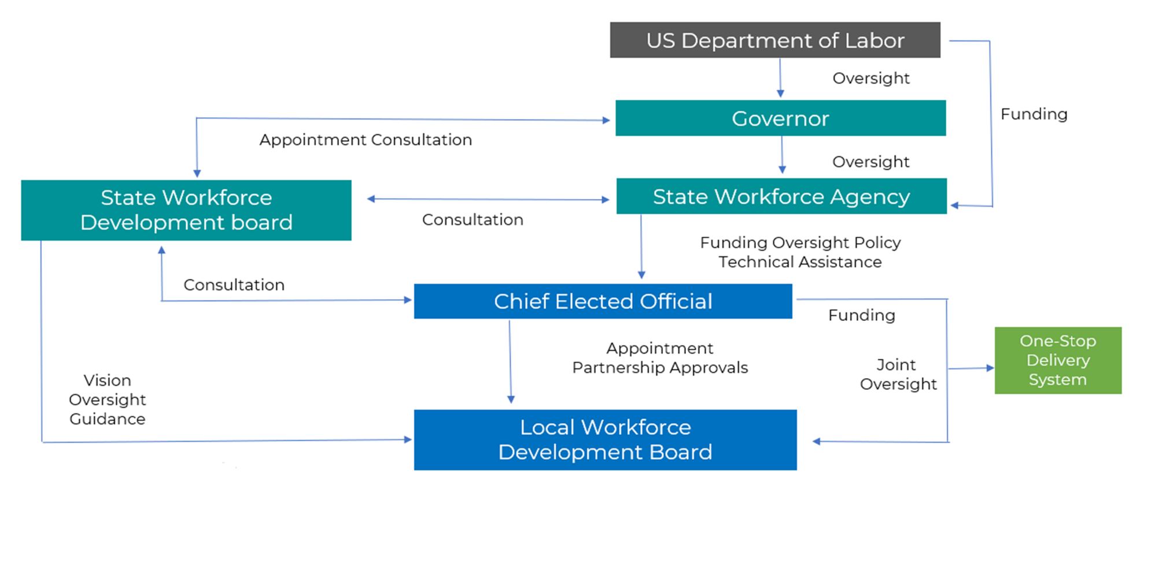

Overview of the Local Workforce Development System
